# Documentation

file：

1. 3d_graph.py
2. App_3d_graph.py

purpose：

Rewrote the two files as Python（carbon.R and shinyApp_carbon.R）This is for the convenience of everyone and encapsulation at the same time.

Package and framework：

The package plotly and the Web framework Dash with Python's interactive charts.

Use guide：

1. 3d_graph.py

When run, follow the prompts to input the path of the main element file in the Console.The browser will automatically open to create an interactive 3D dot map.This file is a demo of the second file.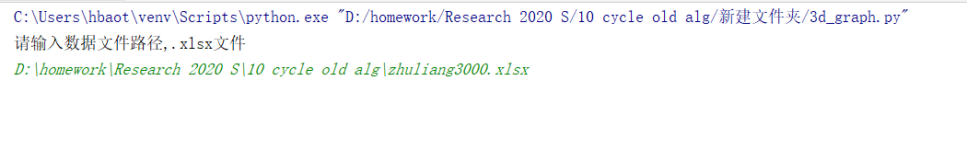

1. App_3d_graph.py

When run, follow the prompts to enter the path of the main element file in the Console.You have to type it twice as often as prompted.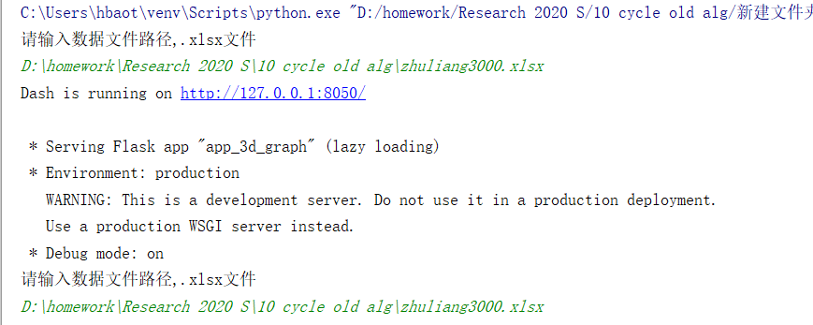

Please click the blue link after entering the two paths to open the browser.(Note that if you enter the path only once, the browser will fail to connect)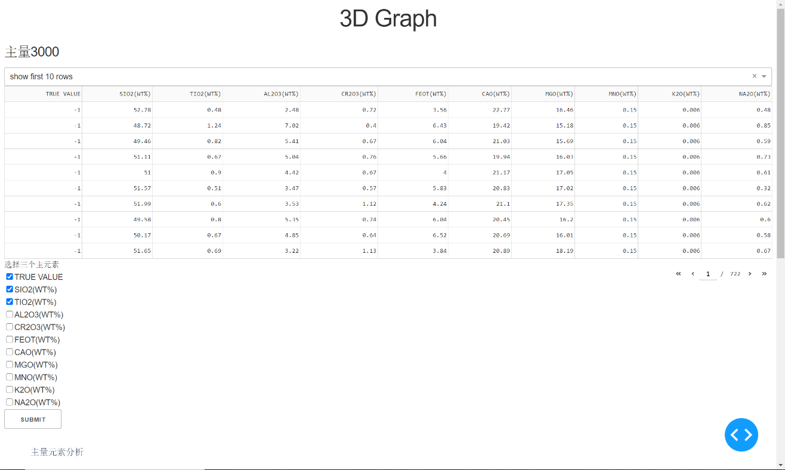

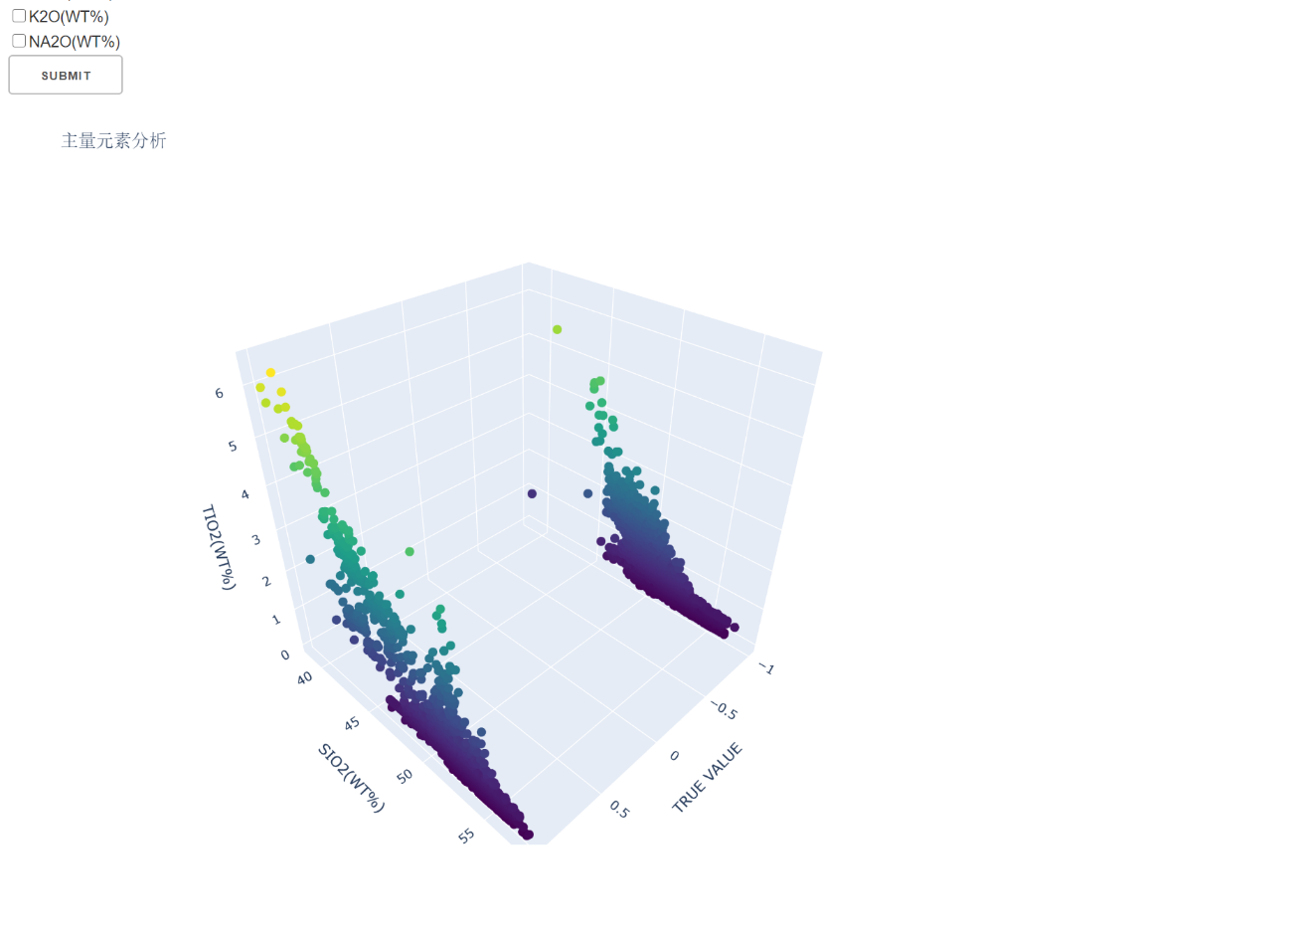

Adjustable parameters：

The number of lines per page of a visual chart

Variables for each axis of the 3D diagram.

Note: Please make sure that three variables are selected as parameters for the 3D diagram and click Submit, otherwise an error will be reported

Please contact me if you have any other request for reference.

Hu Baitao